|  |  |  |
| --- | --- | --- |
| **Nombre**: FRANCISCO PEÑALOZA RODRIGUEZ | | **Matrícula**: 2825146 |
| **Nombre del curso:** Taller de productividad basada en herramientas tecnológicas | **Nombre del profesor**: José Alfredo Jiménez Hernández | |
| **Módulo**: 3 | **Actividad**: 3 | |
| **Fecha**: 10-AGOSTO-2023 | | |
| **Bibliografía**:  **CODIGO** | | |

|  |  |
| --- | --- |
| **Proyecto:** | INDICADORES DE DESEMPEÑO LOGISTICO |
| **Empresa** | IMSS |
| **Patrocinador:** | Lic. Eduardo Amancio Olalde |
| **Líder del proyecto:** | Francisco Peñaloza Rodríguez |
| **Miembros del Equipo:** | Francisco Peñaloza Rodríguez |

**Código para Automatizar el Reporte de Artículos Comprometidos**

Sub Macro3()

'

' Macro3 Macro

'

'LIMPIAR DATOS DE ESTA TABLA'

Application.Goto Reference:="R9C1"

Rows("9:9").Select

Range(Selection, Selection.End(xlDown)).Select

Range(Selection, Selection.End(xlDown)).Select

Selection.Delete Shift:=xlUp

Application.Goto Reference:="R9C1"

'FIN DE LIMPIAR DATOS DE ESTA TABLA'

ChDir "C:\Francisco\REPORTES\suministro"

Workbooks.OpenText Filename:="C:\Francisco\REPORTES\suministro\suministro.txt" _

, Origin:=xlWindows, StartRow:=1, DataType:=xlDelimited, TextQualifier _

:=xlDoubleQuote, ConsecutiveDelimiter:=False, Tab:=False, Semicolon:= _

False, Comma:=False, Space:=False, Other:=False, FieldInfo:=Array(1, 1) _

, TrailingMinusNumbers:=True

Rows("1:1").Select

Selection.Insert Shift:=xlDown

Range("A1").Select

ActiveCell.FormulaR1C1 = "aaa"

Range("A1").Select

Selection.CurrentRegion.Select

Selection.AutoFilter

ActiveSheet.Range("$A$1:$A$50000").AutoFilter Field:=1, Criteria1:=Array( _

"---------------------------------------------------------------------------------------------------------------------------------------" _

, "

", _

"_______________________________________________________________________________________________________________________________________" _

, _

"GPO GEN ESP DI VA U.M CANT. PRES T.P DESCRIPCION No. ORDEN CANTIDAD EDO" _

, "Reporte general de art¡culos comprometidos o en embarque ordenado por unidad" _

), Operator:=xlFilterValues

Range("A1").Select

Selection.CurrentRegion.Select

Selection.SpecialCells(xlCellTypeVisible).Select

Selection.EntireRow.Delete

Rows("1:1").Select

Selection.Insert Shift:=xlDown

Range("A1").Select

ActiveCell.FormulaR1C1 = "aaa"

Range("A1").Select

Selection.CurrentRegion.Select

Selection.AutoFilter

ActiveSheet.Range("$A$1:$A$50000").AutoFilter Field:=1, Criteria1:= _

"=Clas.*", Operator:=xlOr, Criteria2:="=Unidad:*"

Range("A1").Select

Selection.CurrentRegion.Select

Selection.SpecialCells(xlCellTypeVisible).Select

Selection.EntireRow.Delete

Rows("1:1").Select

Selection.Insert Shift:=xlDown

Range("A1").Select

ActiveCell.FormulaR1C1 = "aaa"

Range("A1").Select

Selection.CurrentRegion.Select

Selection.AutoFilter

ActiveSheet.Range("$A$1:$A$50000").AutoFilter Field:=1, Criteria1:= _

"=CONTROL*", Operator:=xlAnd

Range("A1").Select

Selection.CurrentRegion.Select

Selection.SpecialCells(xlCellTypeVisible).Select

Selection.EntireRow.Delete

Range("A1").Select

Selection.CurrentRegion.Select

Selection.AutoFilter

ActiveSheet.Range("$A$1:$A$50000").AutoFilter Field:=1, Criteria1:= _

"=CLAS_PTAL*", Operator:=xlAnd

Range("A1").Select

Selection.CurrentRegion.Select

Selection.SpecialCells(xlCellTypeVisible).Select

Selection.EntireRow.Delete

Range("A1").Select

Selection.CurrentRegion.Select

Selection.Copy

Range("C1").Select

ActiveSheet.Paste

Application.CutCopyMode = False

Range("C1").Select

Selection.CurrentRegion.Select

Selection.Copy

Range("E1").Select

ActiveSheet.Paste

Application.CutCopyMode = False

Range("A1").Select

Selection.CurrentRegion.Select

Selection.AutoFilter

ActiveSheet.Range("$A$1:$A$50000").AutoFilter Field:=1, Criteria1:= _

"=??? ??? ???? ?? ??*", Operator:=xlAnd

Range("A1").Select

Selection.CurrentRegion.Select

Selection.SpecialCells(xlCellTypeVisible).Select

Selection.ClearContents

Range("C1").Select

Selection.CurrentRegion.Select

Selection.AutoFilter

ActiveSheet.Range("$C$1:$C$50000").AutoFilter Field:=1, Criteria1:="="

Range("C1").Select

Selection.CurrentRegion.Select

Selection.SpecialCells(xlCellTypeVisible).Select

Selection.EntireRow.Delete

Range("A50010").Select

ActiveCell.FormulaR1C1 = "fin"

Range("A1").Select

Do

Selection.End(xlDown).Select

If ActiveCell = "fin" Then Exit Do

Selection.EntireRow.Insert , CopyOrigin:=xlFormatFromLeftOrAbove

Selection.End(xlDown).Select

Loop

Range("C50010").Select

ActiveCell.FormulaR1C1 = "fin"

Range("C50013").Select

ActiveCell.FormulaR1C1 = "fin"

Range("C1").Select

Selection.Copy

Selection.CurrentRegion.Select

ActiveSheet.Paste

Do

Selection.End(xlDown).Select

If ActiveCell = "fin" Then Exit Do

Selection.End(xlDown).Select

Application.CutCopyMode = False

Selection.Copy

Selection.CurrentRegion.Select

ActiveSheet.Paste

Loop

Range("A1").Select

Rows("1:1").Select

Application.CutCopyMode = False

Selection.Insert Shift:=xlDown

Range("A1").Select

ActiveCell.FormulaR1C1 = "a"

Range("C1").Select

ActiveCell.FormulaR1C1 = "a"

Range("E1").Select

ActiveCell.FormulaR1C1 = "a"

Range("A1:J50000").Select

Selection.AutoFilter

ActiveSheet.Range("$A$1:$E$50000").AutoFilter Field:=1, Criteria1:="<>"

Range("A2:A50000").Select

Selection.SpecialCells(xlCellTypeVisible).Select

Selection.EntireRow.Delete

ActiveSheet.Range("$A$1:$E$50000").AutoFilter Field:=1

ActiveSheet.Range("$A$1:$E$50000").AutoFilter Field:=3, Criteria1:="="

Range("C1:C50000").Select

Selection.SpecialCells(xlCellTypeVisible).Select

Selection.EntireRow.Delete

Columns("C:C").Select

Selection.Cut

Columns("A:A").Select

ActiveSheet.Paste

Range("A1").Select

Selection.CurrentRegion.Select

Selection.TextToColumns Destination:=Range("A1"), DataType:=xlFixedWidth, _

OtherChar:=":", FieldInfo:=Array(Array(0, 2), Array(12, 1)), _

TrailingMinusNumbers:=True

Range("E1").Select

Selection.CurrentRegion.Select

Selection.TextToColumns Destination:=Range("E1"), DataType:=xlFixedWidth, _

OtherChar:=":", FieldInfo:=Array(Array(0, 2), Array(3, 2), Array(18, 1), Array(22 _

, 1), Array(33, 1), Array(37, 1), Array(100, 1), Array(109, 1), Array(125, 1)), _

TrailingMinusNumbers:=True

Columns("C:D").Select

Selection.Delete Shift:=xlToLeft

Columns("E:E").Select

Selection.Insert Shift:=xlToRight

Range("A1").Select

Selection.CurrentRegion.Select

Selection.Cut

Windows("Macro Remisiones.xlsm").Activate

Range("A9").Select

ActiveSheet.Paste

Windows("suministro.txt").Activate

Range("F1").Select

Selection.CurrentRegion.Select

Selection.Cut

Windows("Macro Remisiones.xlsm").Activate

Range("E9").Select

ActiveSheet.Paste

Range("A1").Select

Windows("suministro.txt").Activate

ActiveWindow.Close

'CREAR ARCHIVO PENDIENTE

ChDir "C:\Francisco\REPORTES\suministro"

Workbooks.Open Filename:="C:\Francisco\REPORTES\suministro\PENDIENTE.xlsx"

Application.Goto Reference:="R2C1"

Rows("2:2").Select

Range(Selection, Selection.End(xlDown)).Select

Range(Selection, Selection.End(xlDown)).Select

Selection.Delete Shift:=xlUp

Windows("Macro Remisiones.xlsm").Activate

Application.Goto Reference:="R9C1"

Range(Selection, Selection.End(xlToRight)).Select

Range(Selection, Selection.End(xlDown)).Select

Selection.Copy

Windows("PENDIENTE.xlsx").Activate

Application.Goto Reference:="R2C1"

ActiveSheet.Paste

ActiveWindow.SmallScroll ToRight:=5

Range("K2").Select

Application.CutCopyMode = False

' ActiveWorkbook.Worksheets("suministro").AutoFilter.Sort.SortFields.Clear

' ActiveWorkbook.Worksheets("suministro").AutoFilter.Sort.SortFields.Add Key:= _

Range ("K1"), SortOn:=xlSortOnValues, Order:=xlAscending, DataOption:= _

xlSortTextAsNumbers

' With ActiveWorkbook.Worksheets("suministro").AutoFilter.Sort

' .Header = xlYes

' .MatchCase = False

' .Orientation = xlTopToBottom

' .SortMethod = xlPinYin

' .Apply

' End With

ActiveWorkbook.Save

'FIN DE CREAR ARCHIVO PENDIENTE

Range("K2").Select

End Sub

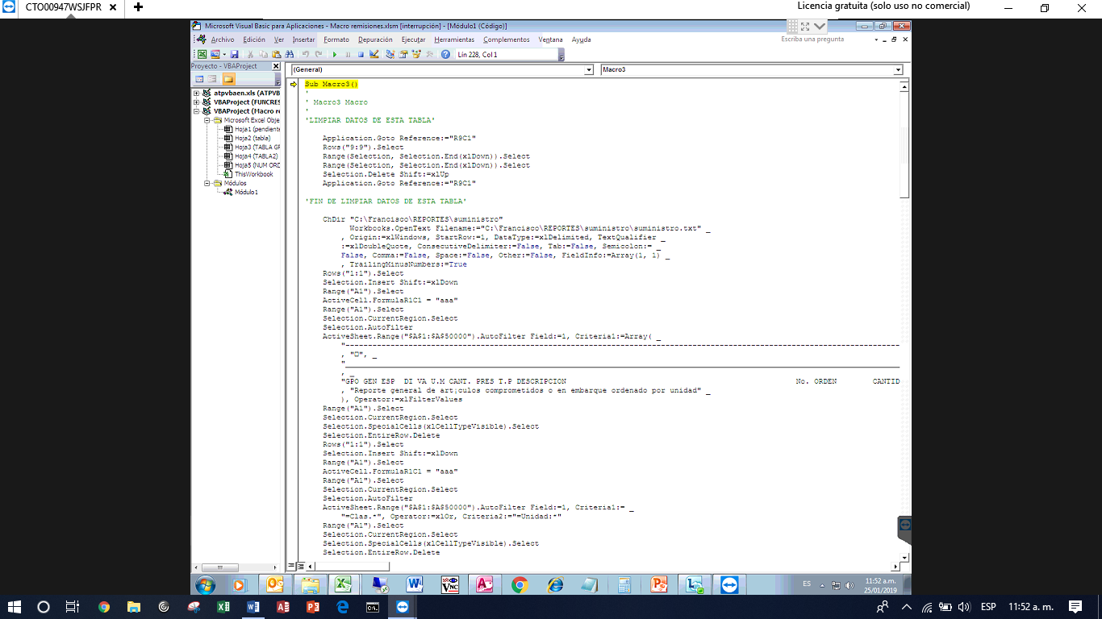

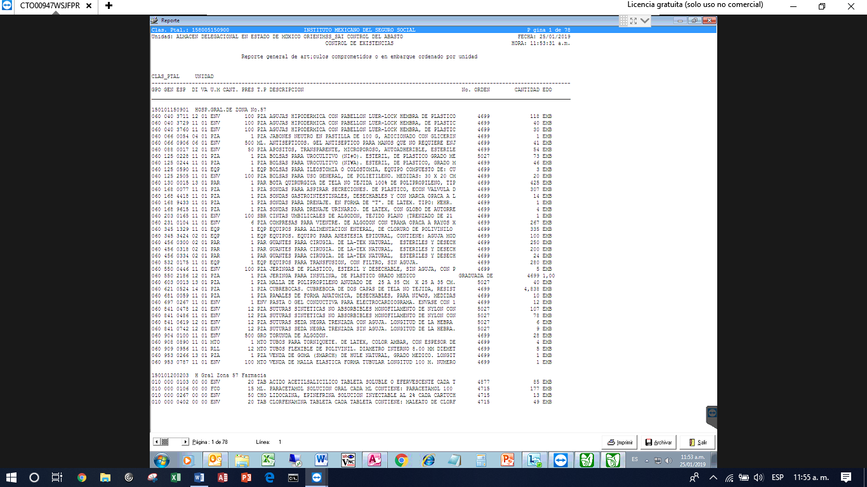

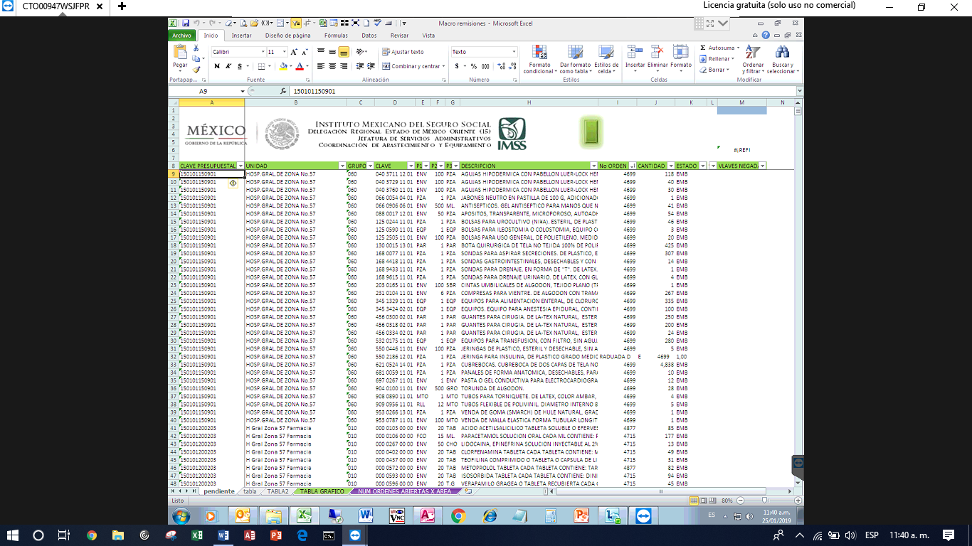

**Query para Generar Reporte de Ordenes Abiertas con Grupo de Suministro**

SELECT DISTINCT INFORMIX_ALM_ORDEN_SUM_D.NO_ORDEN, INFORMIX_ALM_ORDEN_SUM_D.FECHA_ASIGNACION, INFORMIX_ALM_ORDEN_SUM_D.CLAS_PTAL, INFORMIX_ADQ_UNIDADES.DESC_UNIDAD, [000000000PENDIENTE].ESTADO, [000000000PENDIENTE].LINEA, [000000000-REM-UNI].NUM_REM, INFORMIX_ALM_ORDEN_SUM_D.GPO, [000000000-REM-UNI].LINEA, [000000000-REM-UNI].FECHA_REMISION, [000000000CTV].TIPO, [000000000CTV].N_CTV, [000000000CTV].F_SALIDA, [000000000CTV].H_SALIDA, [000000000CTV].CHOFER, [000000000CTV].F_ENTREGA, [000000000-REM-UNI].FECHA_ALTA_UNIDAD, [000000000UNIDAD].RUTA_1, [000000000UNIDAD].RUTA_2, [000000000-REM-UNI].FECHA_REGISTRO, INFORMIX_ALM_ORDEN_SUM_D.GPO, [F_SALIDA] & " " & [H_SALIDA] AS [FECHA CTV], [000000000PENDIENTE]![ESTADO] & [000000000PENDIENTE]![LINEA] & [NUM_REM] & [000000000-REM-UNI]![LINEA] AS STU_2, Last([000000000-REM-UNI].NUM_DEVREM) AS ÚltimoDeNUM_DEVREM, Last([000000000-20-CLAVES-NEGADAS].IMPORTANCIA) AS ÚltimoDeIMPORTANCIA

FROM ((((INFORMIX_ALM_ORDEN_SUM_D LEFT JOIN ([000000000-REM-UNI] LEFT JOIN 000000000CTV ON [000000000-REM-UNI].NUM_REM = [000000000CTV].REMISION) ON (INFORMIX_ALM_ORDEN_SUM_D.VAR = [000000000-REM-UNI].VAR) AND (INFORMIX_ALM_ORDEN_SUM_D.DIF = [000000000-REM-UNI].DIF) AND (INFORMIX_ALM_ORDEN_SUM_D.ESP = [000000000-REM-UNI].ESP) AND (INFORMIX_ALM_ORDEN_SUM_D.NO_ORDEN = [000000000-REM-UNI].NO_ORDEN_SUMINISTRO)) LEFT JOIN INFORMIX_ADQ_UNIDADES ON INFORMIX_ALM_ORDEN_SUM_D.CLAS_PTAL = INFORMIX_ADQ_UNIDADES.CLAS_PTAL) LEFT JOIN 000000000PENDIENTE ON (INFORMIX_ALM_ORDEN_SUM_D.NO_ORDEN = [000000000PENDIENTE].[No ORDEN]) AND (INFORMIX_ALM_ORDEN_SUM_D.VAR = [000000000PENDIENTE].C4) AND (INFORMIX_ALM_ORDEN_SUM_D.DIF = [000000000PENDIENTE].C3) AND (INFORMIX_ALM_ORDEN_SUM_D.ESP = [000000000PENDIENTE].C2)) LEFT JOIN [000000000-20-CLAVES-NEGADAS] ON (INFORMIX_ALM_ORDEN_SUM_D.GPO = [000000000-20-CLAVES-NEGADAS].GPO) AND (INFORMIX_ALM_ORDEN_SUM_D.GEN = [000000000-20-CLAVES-NEGADAS].GEN) AND (INFORMIX_ALM_ORDEN_SUM_D.ESP = [000000000-20-CLAVES-NEGADAS].ESP) AND (INFORMIX_ALM_ORDEN_SUM_D.DIF = [000000000-20-CLAVES-NEGADAS].DIF) AND (INFORMIX_ALM_ORDEN_SUM_D.VAR = [000000000-20-CLAVES-NEGADAS].VAR)) LEFT JOIN 000000000UNIDAD ON INFORMIX_ALM_ORDEN_SUM_D.CLAS_PTAL = [000000000UNIDAD].CLA_PTAL

GROUP BY INFORMIX_ALM_ORDEN_SUM_D.NO_ORDEN, INFORMIX_ALM_ORDEN_SUM_D.FECHA_ASIGNACION, INFORMIX_ALM_ORDEN_SUM_D.CLAS_PTAL, INFORMIX_ADQ_UNIDADES.DESC_UNIDAD, [000000000PENDIENTE].ESTADO, [000000000PENDIENTE].LINEA, [000000000-REM-UNI].NUM_REM, [000000000-REM-UNI].LINEA, [000000000-REM-UNI].FECHA_REMISION, [000000000CTV].TIPO, [000000000CTV].N_CTV, [000000000CTV].F_SALIDA, [000000000CTV].H_SALIDA, [000000000CTV].CHOFER, [000000000CTV].F_ENTREGA, [000000000-REM-UNI].FECHA_ALTA_UNIDAD, [000000000UNIDAD].RUTA_1, [000000000UNIDAD].RUTA_2, [000000000-REM-UNI].FECHA_REGISTRO, INFORMIX_ALM_ORDEN_SUM_D.GPO, [F_SALIDA] & " " & [H_SALIDA], [000000000PENDIENTE]![ESTADO] & [000000000PENDIENTE]![LINEA] & [NUM_REM] & [000000000-REM-UNI]![LINEA], INFORMIX_ALM_ORDEN_SUM_D.GPO

HAVING (((INFORMIX_ALM_ORDEN_SUM_D.GPO)="010" Or (INFORMIX_ALM_ORDEN_SUM_D.GPO)="020" Or (INFORMIX_ALM_ORDEN_SUM_D.GPO)="030" Or (INFORMIX_ALM_ORDEN_SUM_D.GPO)="040"));

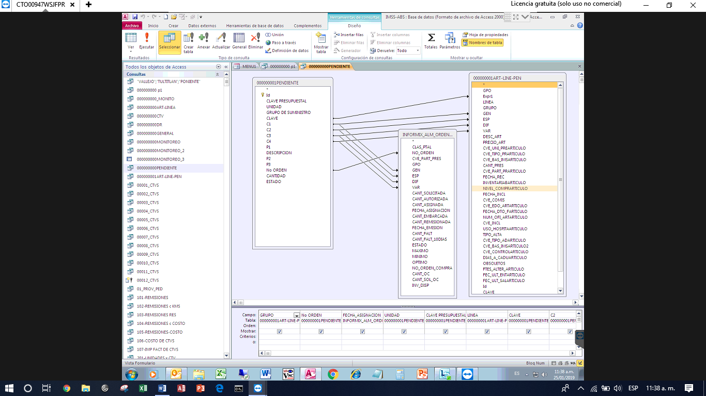

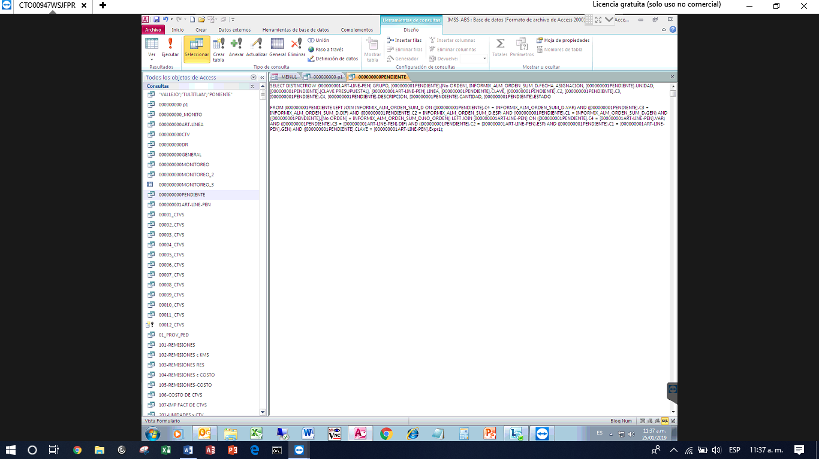

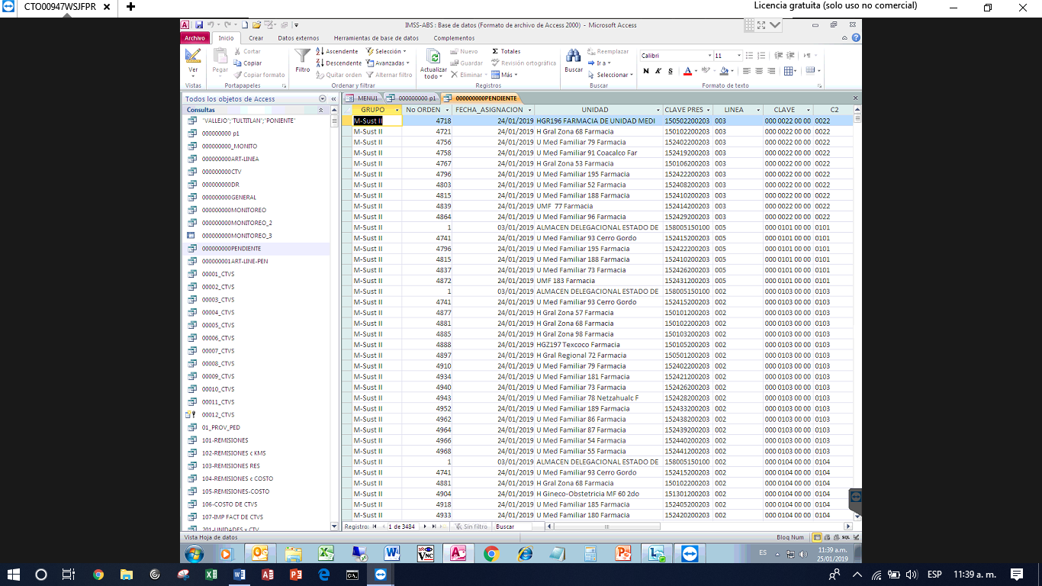

SOLICITUD DE REMISIONES CAPTURADAS EN UNIDAD MEDICA

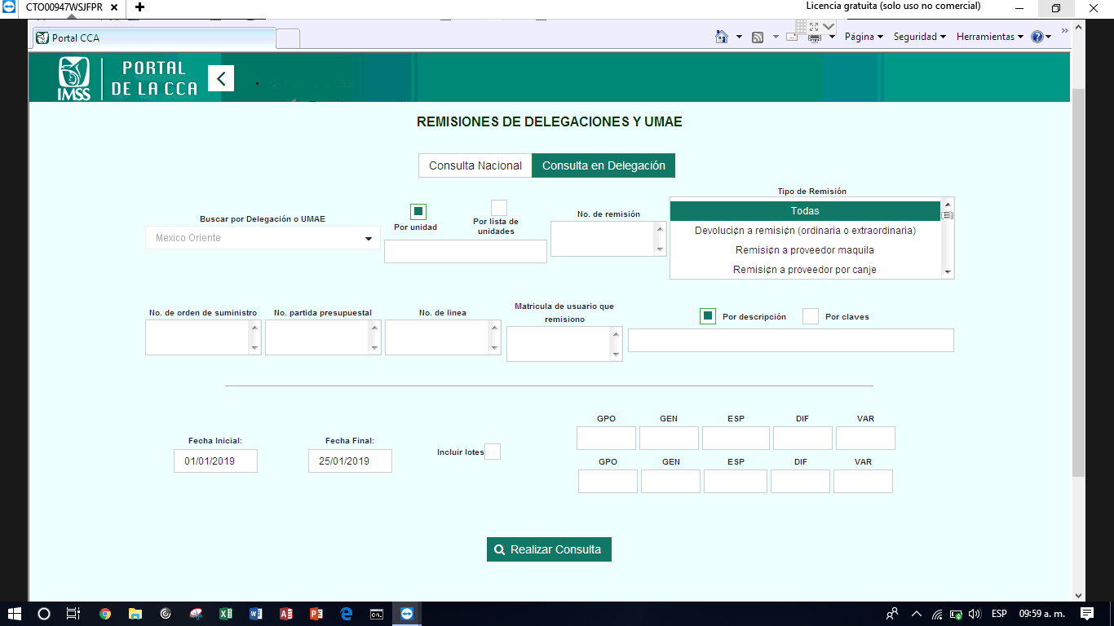

SE GENERA EL REPORTE Y SE EXPORTA A EXCEL PARA DESPUES EXPOPRTARLO A ACCES

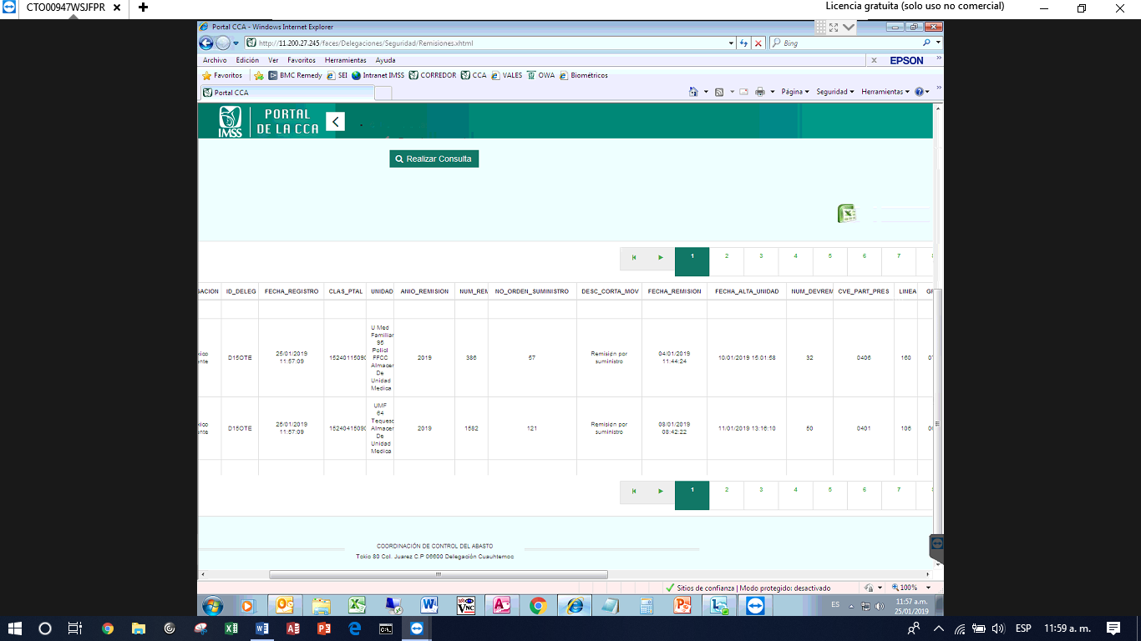

SE GENERA QUERY PARA COMPROBAR QUE ORDENES HAN CUMPLIDO CON TODO ES CICLO LOGISTICO

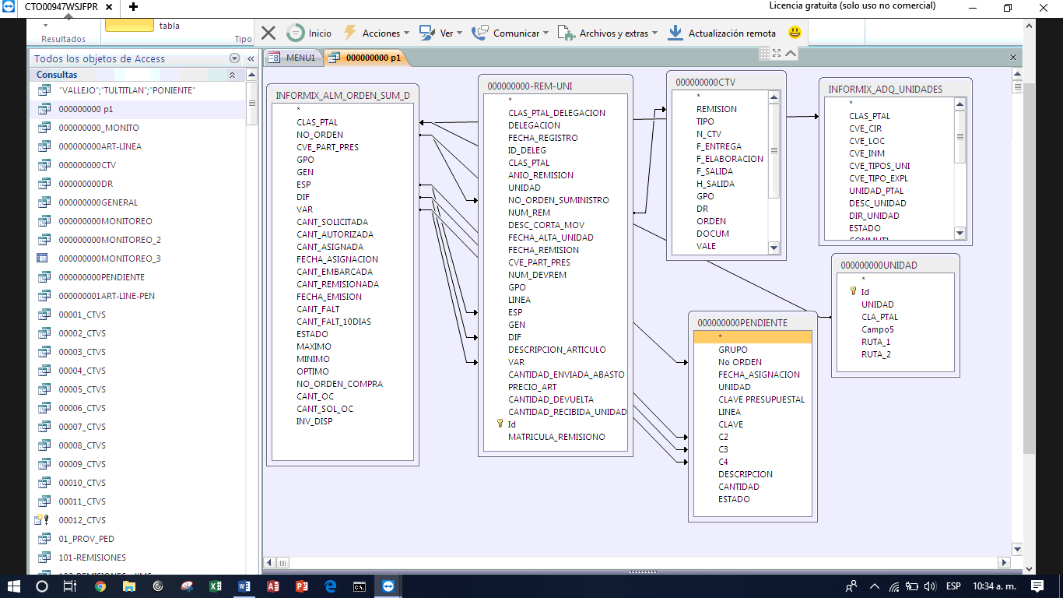

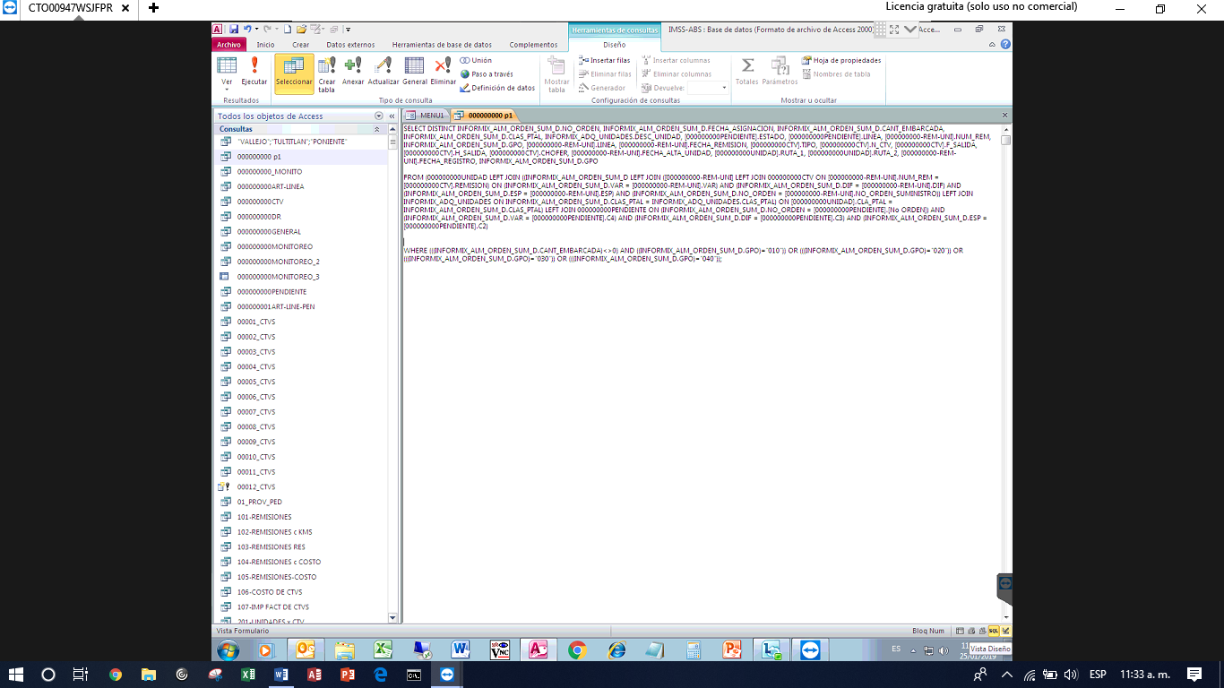

REPORTE DONDE PODEMOS APRECIAR QUE ORDENES DE SUMINISTRO SE HAN REMISIONADO, EMBARCADO Y CAPTURADO EN LA UNIDAD MEDICA

